ANALYSIS AND VISUALISATIONS OF WORLD HAPPINESS REPORT

TEAM MEMBERS:

MARIYA BIJU (20BDA61),

BISMI JOSEPH (20BDA07),

RAMYA GUNAM (20BDA33)

**INTRODUCTION:**

The data for this project was obtained from “Kaggle.com”. The data has information about 158 different countries (rows) and 12 different variables (columns) of 3 different years (2015, 2016, 2017). Variables include Happiness score, Region, country, generosity, happiness rank, life expectancy, freedom, government corruption, social support, dystopia residual.

**PROBLEM STATEMENT:**

ANALYSIS AND VISUALISATIONS OF WORLD HAPPINESS REPORT

**METHODOLOGY:**

Visualised the data using correlation plots, bar & line charts, histograms. Happiness score is a dependent variable.

ANALYSIS & VISUALISATIONS ARE DONE FOR THE FOLLOWING

* Strength of correlation between happiness score and other variables.
* Plotting happiness score, GDP per capita, social support, life expectancy by regions.
* Finding out top 10 and last 10 happiest countries.
* Does GDP & happiness score have increasing or decreasing trend throughout the years?
* Distribution of each variable
* Spread of the data.

**DATASET:**

Description of the variables in the dataset are given below

**Country**: Name of the country.

**Region**: Region the country belongs to.

**GDP per capita**: GDP per capita is a measure of a country's economic output that accounts for its number of people.

**Social support**: Social support means having friends and other people, including family, to turn to in times of need or crisis to give you a broader focus and positive self-image. Social support enhances quality of life and provides a buffer against adverse life events.

**Life expectancy**: Healthy Life Expectancy is the average number of years that a new born can expect to live in "full health"—in other words, not hampered by disabling illnesses or injuries.

**Freedom to make life choices**: Freedom of choice describes an individual's opportunity and autonomy to perform an action selected from at least two available options, unconstrained by external parties.

**Generosity**: The quality of being kind and generous.

**Government corruption**: The Corruption Perceptions Index (CPI) is an index published annually by Transparency International since 1995 which ranks countries "by their perceived levels of public sector corruption, as determined by expert assessments and opinion surveys.

**Dystopia**: Each country is compared against a hypothetical nation that represents the lowest national averages for each key variable and is, along with residual error, used as a regression benchmark.

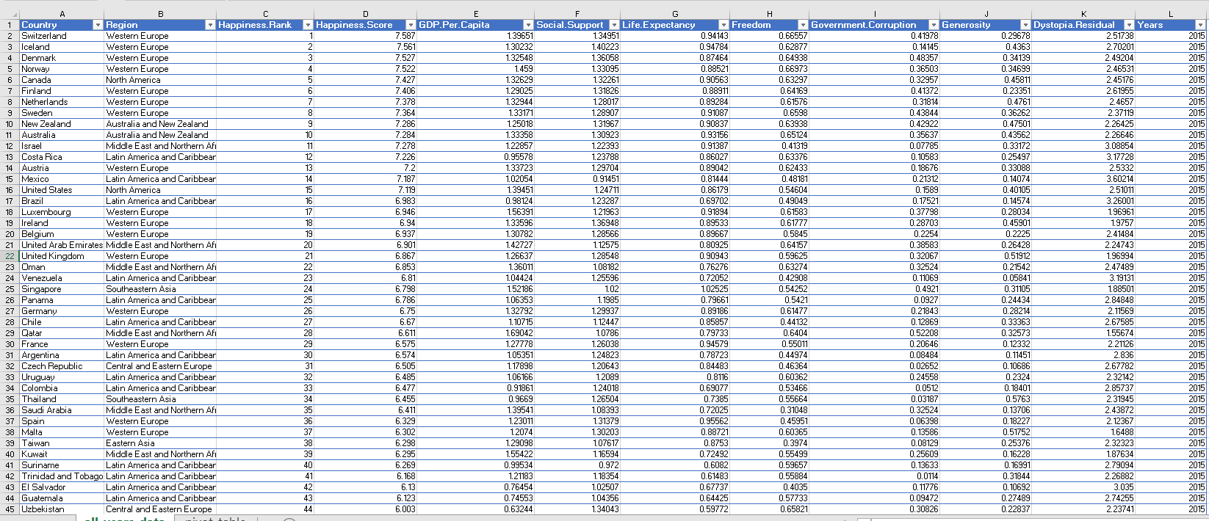

**RESULTS:**

* Life expectancy, GDP per capita, Social support are highly correlated with happiness score.
* Found out there is an increasing trend in GDP.
* Visualised GDP for few countries throughout the years.

**DATASET**

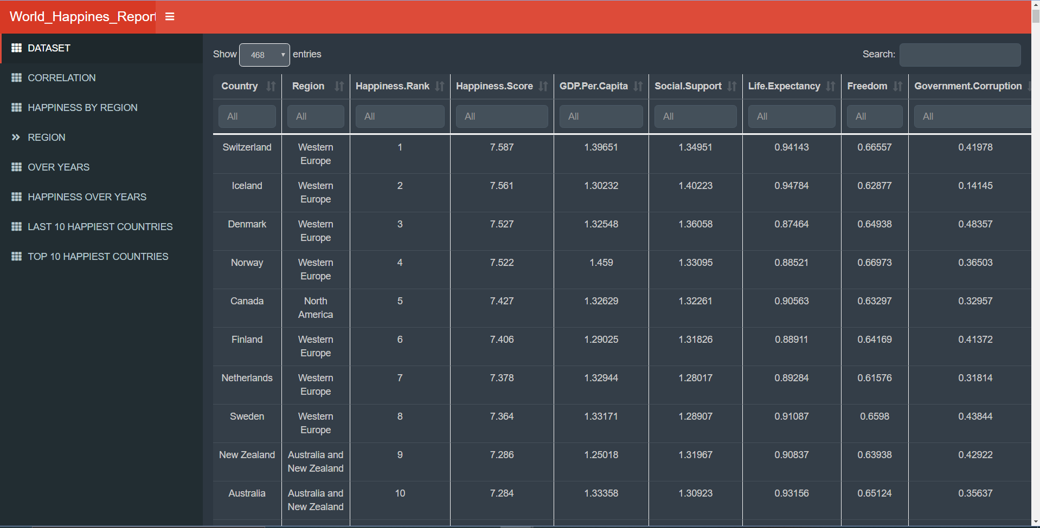

CORRELATION PLOT

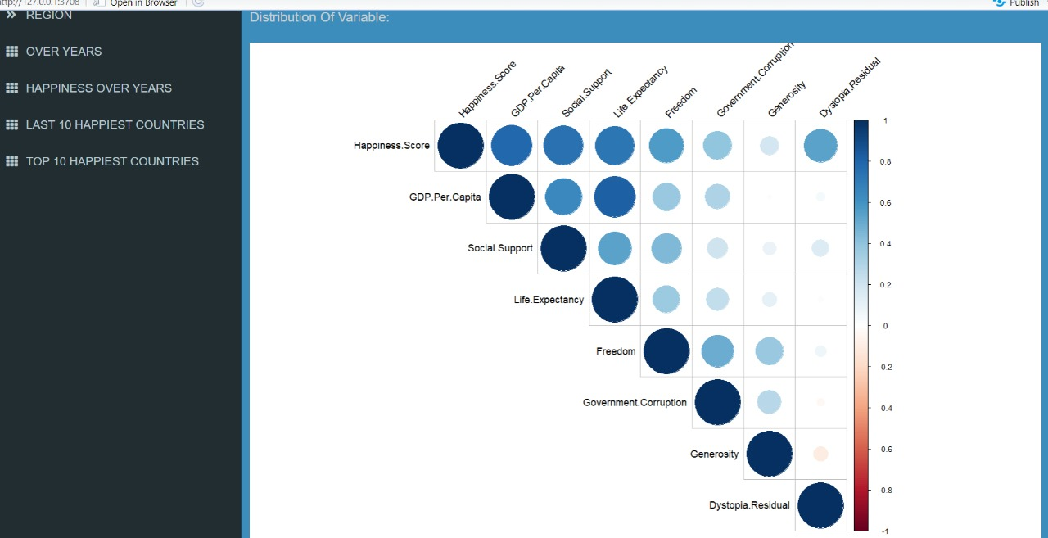

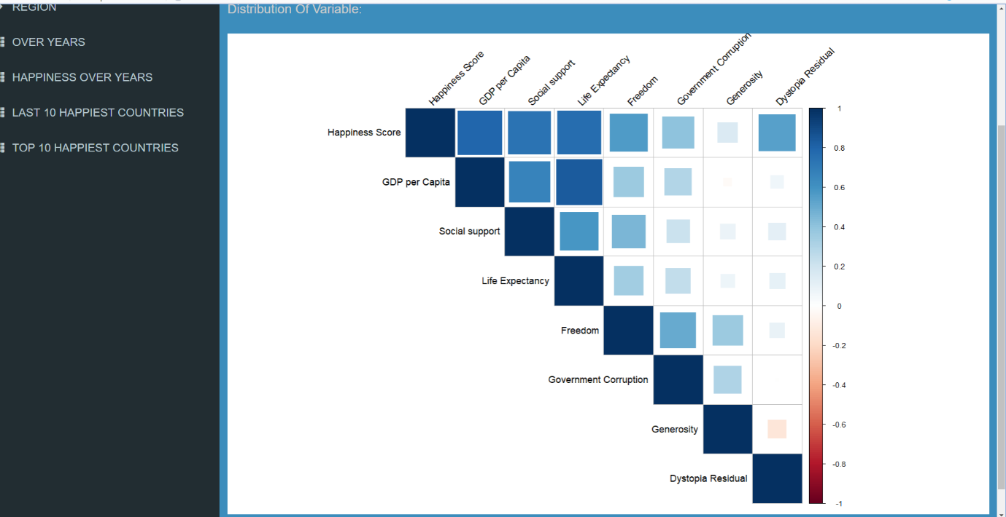

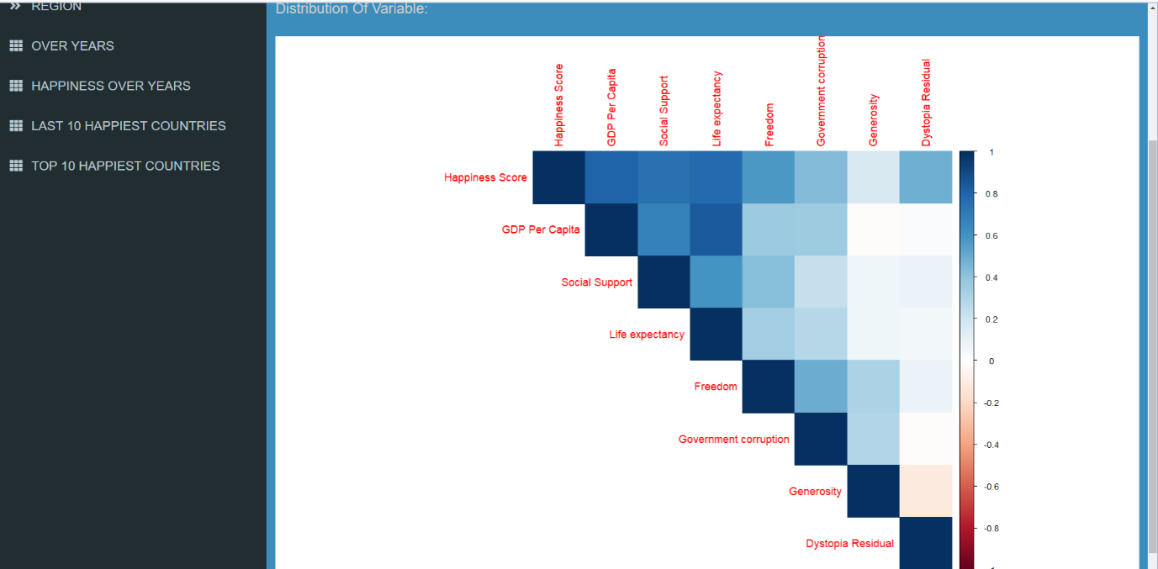

HAPPINESS BY REGION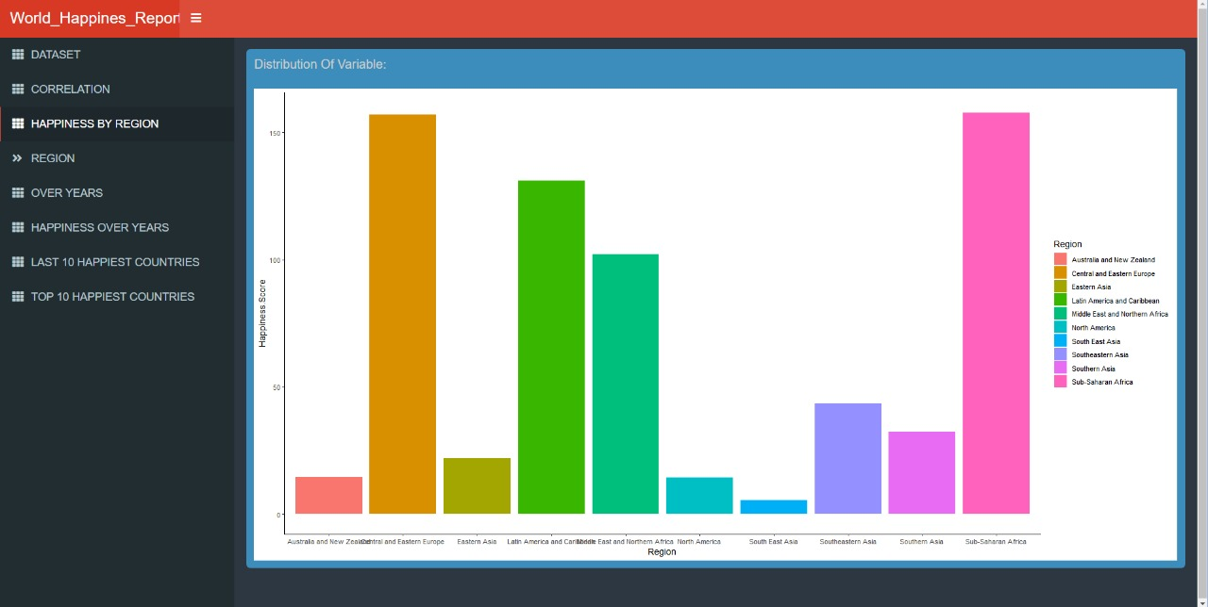

REGIONS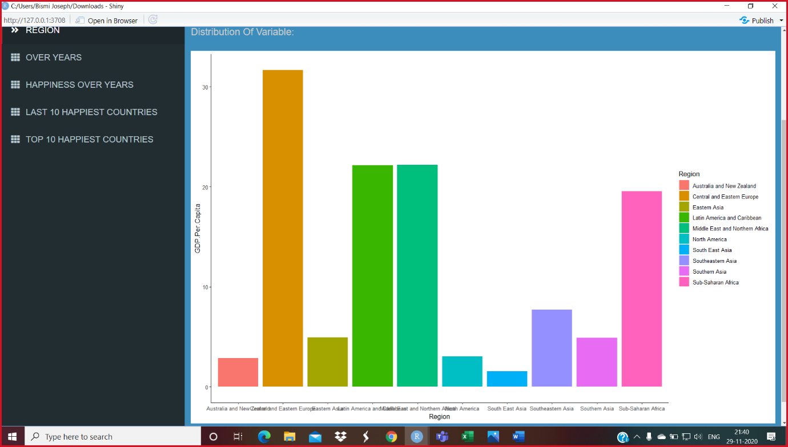

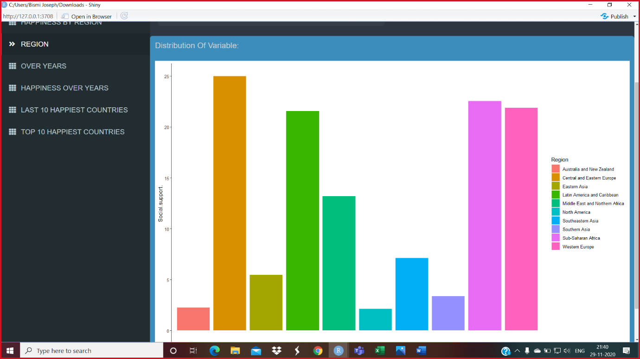

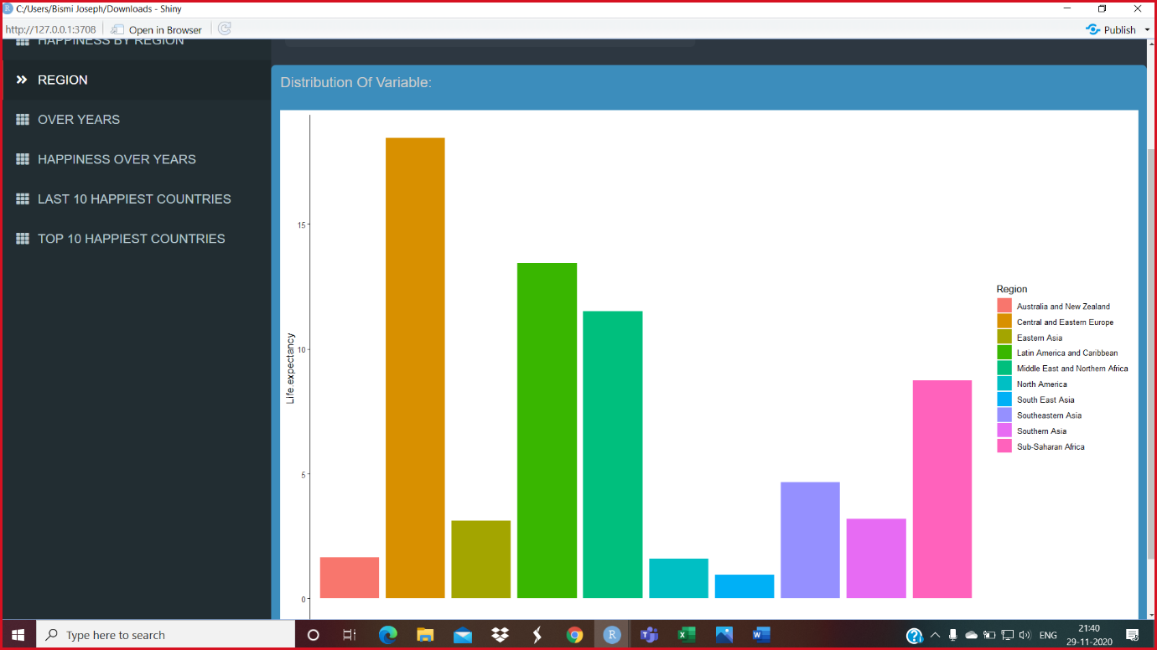

HAPPPINESS OVER YEARS

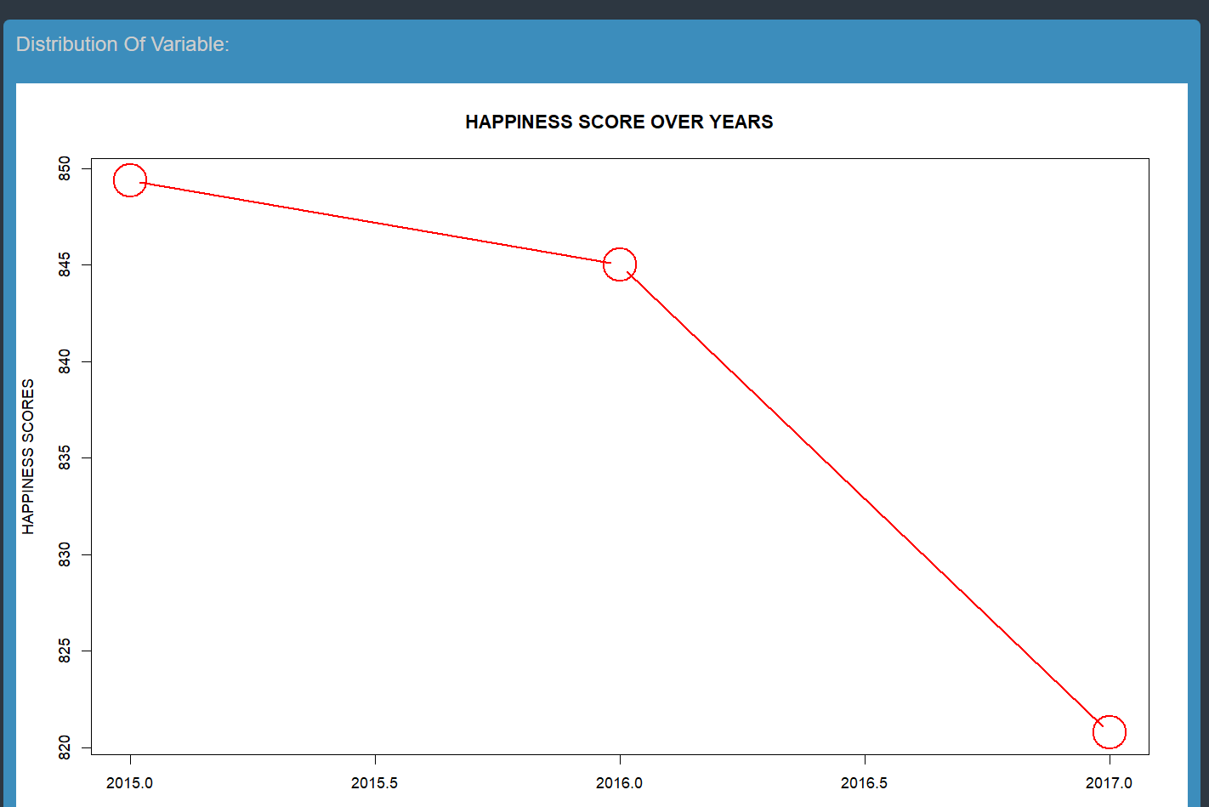

OVER YEARS

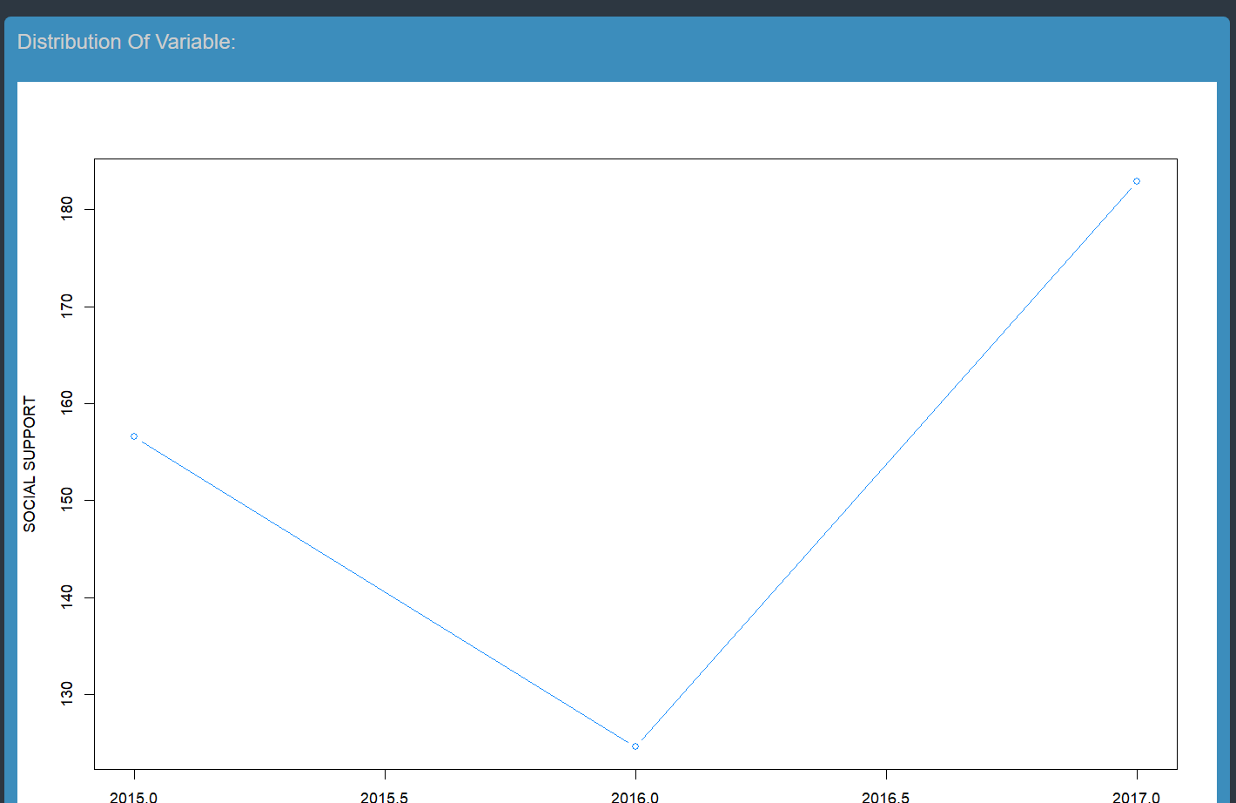

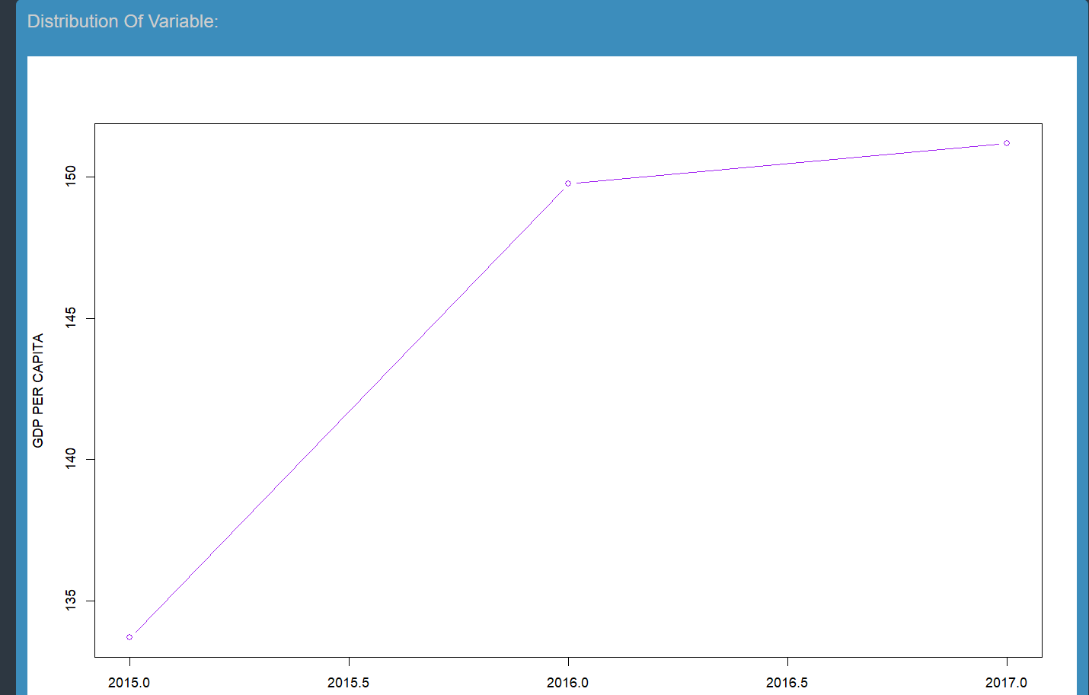

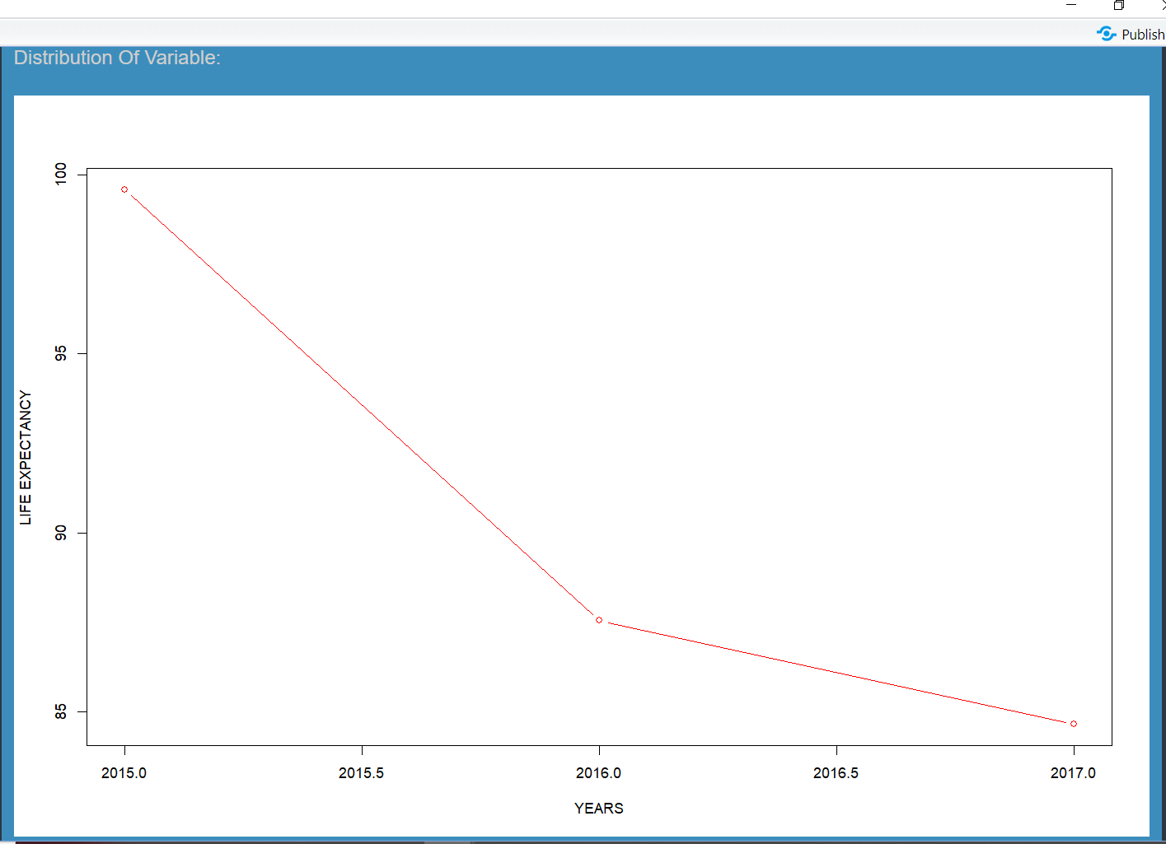

LAST 10 HAPPIEST COUNTRIES

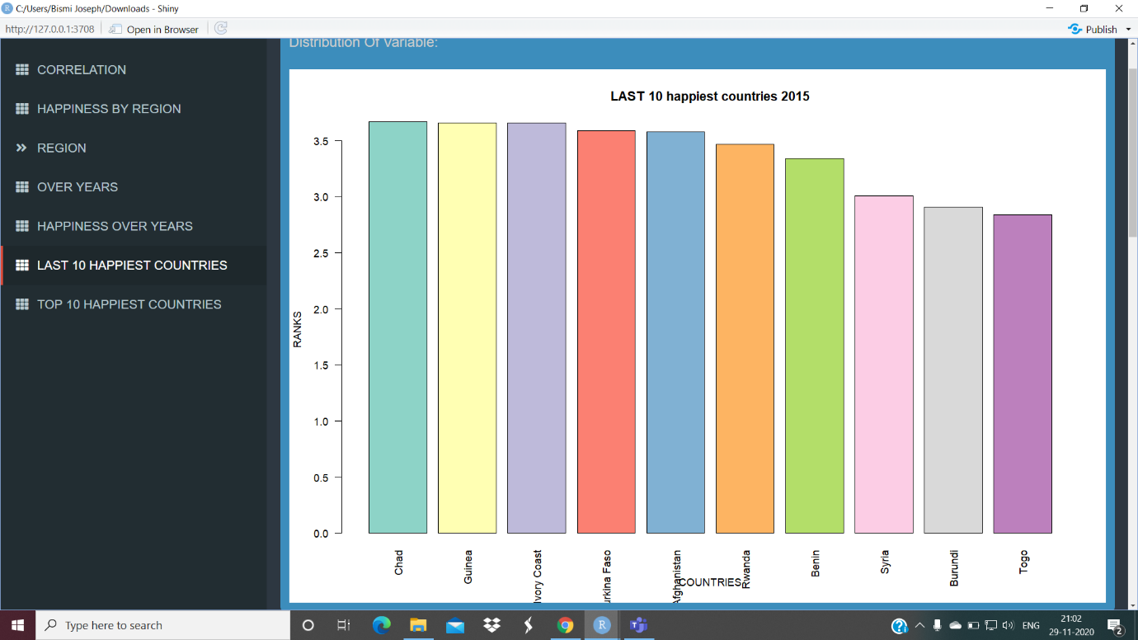

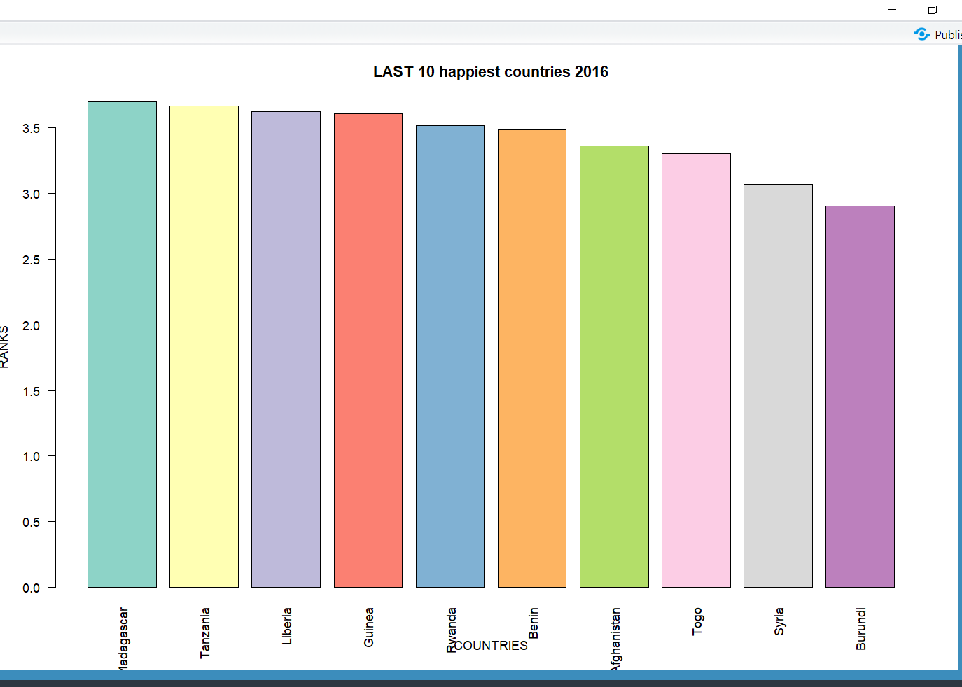

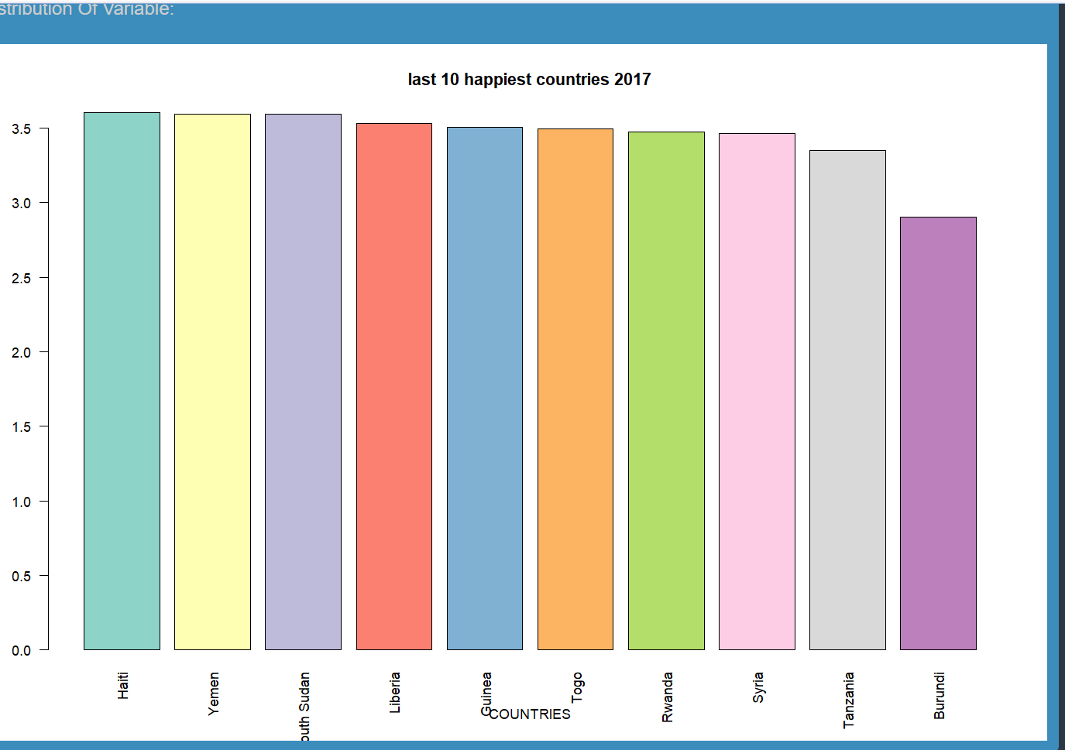

TOP 10 HAPPIEST COUNTRIES

